KRONOS FALCON CLOUD - WFD Patch Manager

End User’s Guide for WFD Patch Manager

Version 1.0

21 August 2020

Document Control

|  |  |
| --- | --- |
| Filename | KRONOS FALCON CLOUD - WFD Patch Manager |
| Original Author(s) | Sagar Saxena & Mayur Kapoor |
| Publish Date | 08/13/2020 3:18 PM |
| Sharepoint Location | <insert link> |

Change History

|  |  |  |  |
| --- | --- | --- | --- |
| **Revision** | **Date** | **Contributors** | **Description** |
| V1.0 |  |  | Initial draft |
|  |  |  |  |

This document or any part thereof may not be reproduced in any form without the written permission of Kronos Incorporated. All rights reserved. Copyright 2015.

Kronos, the Kronos logo, Kronos Touch ID, Visionware, Workforce Accruals, Workforce Central, and Workforce TeleTime are registered trademarks, and Kronos 4500, Kronos 4500 Touch ID, Smart View, Momentum, Workforce Activities, Workforce Attendance, Workforce Connect, Workforce Employee, Workforce HR, Workforce Leave, Workforce Manager, Workforce Payroll, Workforce Record Manager, Workforce Scheduler, Workforce Scheduler with Optimization, and Workforce Timekeeper are trademarks of Kronos Incorporated or a related company in the United States. For a complete list of Kronos Trademarks, see <http://www.kronos.com/Trademarks.htm>.

iSeries is a trademark of IBM.

Oracle is a registered trademark of Oracle Corporation.

Microsoft, Windows 95, Windows 98, Windows 2000 and Windows XP are registered trademarks, and Windows NT is a trademark of Microsoft Corporation in the United States and/or other countries.

Crystal Reports is a registered trademark of Business Object SA.

When using and applying the information generated by Kronos products, customers should ensure that they comply with the applicable requirements of federal and state law, such as the Fair Labor Standards Act. Nothing in this document shall be construed as an assurance or guaranty that Kronos products comply with any such laws.

Approvals Distribution List

|  |  |  |  |
| --- | --- | --- | --- |
| Copy No | Approver Name | Title | Approval Date |
|  |  |  |  |
|  |  |  |  |
|  |  |  |  |
|  |  |  |  |
|  |  |  |  |
|  |  |  |  |

DOCUMENT Conventions

|  |  |
| --- | --- |
| **Convention** | **Description** |
|  | Provides a description or explanation of the section and may include an example. Remove this blue background text box prior to document review and release. |

Table of Contents

End User’s Guide for WFD Patch manager 1

1 Overview 7

1.1 Background 7

1.2 Purpose of this Document 7

2 WFD Patch Manager END USEr’s guide 8

2.1 Overview 8

2.2 Pre-Requisite for WFD patch Manager 9

# Overview

## Background

WFD Patch Manager makes it easier to manage patches on servers with the ability to patch machines, organize ino groups. It is built to integrate with Rightscale to apply patches on custom schedules.

Patch Manager is designed to help you proactively identify which deployment and deployment’s instance need to be patched.

## Purpose of this Document

This document provides detailed information about the How Tos, FAQs etc. The primary objective is to provide the end user with clear steps so that they can properly set up Patch Manager.

# *WFD Patch MANAger End USEr’s guide*

## *Overview*

Patch Manager will be using the Rightscale Project refresh token as an authentication module. We can begins with deployment’s discovery phase, once RS project authentication is successful.

## *Pre-Requisite for WFD Patch Manager*

* Install Python v3.8+ and pip19+

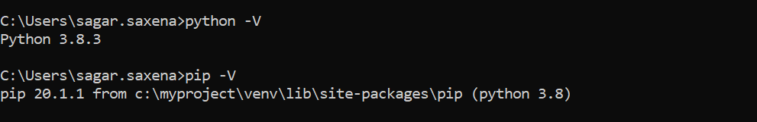

* Add environment variables in local machine   
  Open the Start Search, type in “env” 🡪 and choose “Edit the system environment variables” 🡪 Click the “Environment Variables…” button 🡪 Set the environment variables as needed. The New button adds an additional variable.

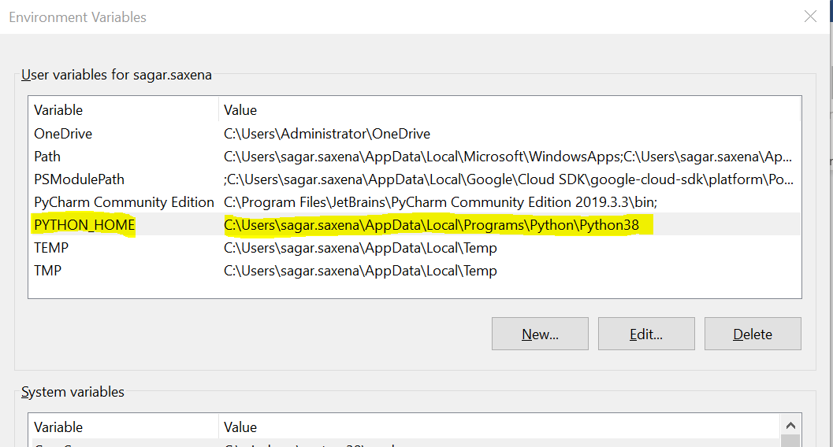

* Download code zip file from goole bucket <https://console.cloud.google.com/storage/browser/_details/koss01-cloudops-bucket/patch_manager.zip?project=gcp-koss01> in D:\ drive.
* Now Run below command to install all required packages for application  
    
  *pip install appdirs Babel certifi chardet click et-xmlfile filelock Flask Flask-Babel Flask-Table Flask-WTF idna itsdangerous jdcal Jinja2 MarkupSafe openpyxl pip pytz requests setuptools uritools urlextract urllib3 Werkzeug wheel WTForms*
* Start Python application from command prompt  
    
  python D:\myproject\Flask\login.py
* Now , hit *localhost:5000/login* from local browser to access the patch manager.